Technology in health care
Student’s name
Course Code/name
University affiliation
Professor:
Date:

Technology is a force that cannot be ignored in the improvement and development of the health sector. In the recent days, technology has played a major role in affecting the lives of patients and the general population. There are a number of ways technology has played a major role in changing the health care. For example, in data collection, recording, provision of medication and surgeries, research among many other key areas. The coordination of technology in the health sector has made treatment easier and accessible. Technology has opened up many avenues in exploration and research in the field of medicine.
Explain how you would lobby your legislators or local government for funds to support your issue or trend.
I would work with State as well as the local organizations financed by the government and allowed to work straightforwardly on arrangement related issues over their proportional branches of state and local healthcare. Working with the local and state health care organization is easy to push for the agenda of technology in hospitals e.g. purchase of modern health equipment and technologically engineered medicine. These agencies/organizations have power and a say in the health sector and once they suggest on something about healthcare, the legislators will have a look at it and consider it.
I would work with the Non-government organizations, which may likewise take part in a scope of technology strategy related exercises. In any case, these non-government organizations don't have perceived government authoritative connections, and their admissible exercises utilizing Federal assets are in this way more compelled than state and the local institutions. In most cases, the Non-government organizations work with foreign or international bodies, which push for the development of people’s lives. These Non-government organizations are able to pull resources into the health sector towards a common goal of having technological advancements. The Non-government organizations also work with the government and legislators who come together and can cause a change in the health sector (Russell, 2015).
Taking part in health care exercises such as campaigning through workshops and rallies, can embrace legislators who have an interest in health care. Those exercises, incorporate featuring and interpreting general wellbeing of patients in the hospitals, gathering and breaking down information that can be useful in analyzing the need of technology in the health sector, distributing and dispersing of research information to the legislators, executing counteractive action systems and recommendations, and cultivating coalition building and agreement on general wellbeing activities, giving initiative and encouraging legislators to come up with the right policies based on the recommendations provided (Russell, 2015).
Share why you chose the specific topic
I chose this specific topic because, technology is key in almost every field today. Fitness, nutrition and health is among the best of all the human needs today and there has been relentless efforts in the recent past to make advancements in the health sector through engineering and technological projects performed with an end goal to persistently expand the stretch of health care provision. In search of quality medication, it can only be pursued with fresh systems that are useful in delivering quality healthcare in order to support the wellbeing of patients. Everyone knows that life can be profitable alongside with the assistance of mechanical expertise healthcare facilities around in the hospitals and any patient would like to visit an healthcare facility that is fully equipment with the necessary medication and technological equipment. Because of mechanical expertise, clinics have a tendency to be more equipped at providing the patient with the essential needs (Shekelle, et. al., 2014).
Technology in the health care system has helped in different hospital health care provision activities such as surgeries and medication as well as quality care strategy, innovation in the clinical setting. For example, private doctor's facilities as of now are more powerful at completing basic and furthermore lifetime unsafe surgeries because of the reality in regards to innovative models used in medical procedures. Currently, many healthcare facilities have the so referred to as CAS and in addition Pc guided Medical methodology that is by and large known as the real PC or PC and which uses guided therapeutic systems (Russell, 2015).
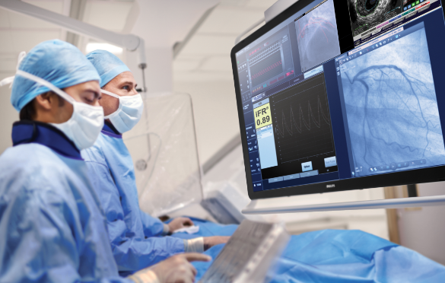
Utilizing this technique is frequently used by most restorative specialists in some medical procedure works specifically regarding the matter of spinal conditions, otolaryngology, and furthermore orthopedic activities. As to research facilities, the use of advanced contraptions and hardware to execute analytic checks, which can be considerably more right notwithstanding, direct when contrasted with earlier with when everything was manually crafted by hand.
In any case, therefore specialized technology in healthcare, combined with a noteworthy volume of qualified professionals may likewise be useful when it comes to the fruition of the agenda of equipping health care facilities with the right equipment and quality medicine. Technological innovation has beset exactly how hospital representatives associate from the therapeutic focus or maybe far from medicinal focus. Among which can be utilizing this thusly named "telemedicine" which is depicted as the utilization of mechanized instruments to have the capacity to screen or impart actualities to another medicinal services ability with regards to offering crucial information to support the patient’s health (Kabene & IGI Global., 2017). Significance of Technology in Health Care and clinics also includes the provincial health care devices getting to home based such that not at all times that the patient need to visit the health care facility in order to get health care services administered (Miniati, Iadanza and Dori, 2016).
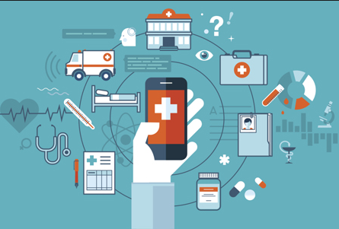
It is just a matter of having a phone and dial and this gets the patient to the health care point of need without necessarily going to a social insurance office or healthcare facility (Sheikh, et. al., 2017).
Presently, health care delivery may likewise have happened through the utilization of PC frameworks. Additionally drug specialists inside the hospital can do predominant with the assistance of unrivaled projects wherever through an assortment of therapeutic medications as well as prescriptions in an expert way through direct utilization of technological health care systems. Examination checks for instance CT scans; MRI and X-ray as a rule are associated with technology plan advancements that happen to be most exceptionally supportive in the center. Spill meters, pace makers to the general population in the strenuous social insurance gadget, syringe pumps are currently used and that is basic to guarantee the living of the individual is normally administered through technological equipment (Balgorsky, 2014).
The use of innovation based on technology from the facility building all the way to provision of medical care is important as long as the health care facility, department of even the sector has to grow. Without the help of technology in medicine, surgeries, nutrition, the presence of a medical facility could be outlandish regardless of the qualification of the doctor. Therefore, it is logical to say that innovation is generally one specific significant issue in which broadens the doctor's facility, provision of health care and at large, affects positively the health of the patients. Because of these sort of critical specialized achievement innovations in telemedicine has turned out to be enhanced, improved and healthcare has turned out to be helpful (Ball & Douglas, 2016).
The current relevance of material, and how it is integrated into clinical practice
The materials used in the research are relevant in the topic because they focus on the current issues in the health sector such as the application of technology in health care, the emerging trends in the field of medicine, quality healthcare provided by health care professionals etc. For example in medication, in surgical procedures and so on. The materials on the other hand, are current and up-to-date thus they provide the right information that is needed in this topic. The best professionals in the world who have had a lot of exposure in the field of medicine have also authored the materials. It is therefore a guarantee that the information provided in the materials is well analyzed and contains the current issues/trends in healthcare as the topic/course demands.
How the information is used in clinical setting
Information on technology innovations in useful in the manner in which health care is administered in health care facilities. For example, information gives insight of the usefulness of technology. Health information technology describes the different management efforts that are needed in the sector in order to make health care provision more technical and purposeful. Technology in health care helps in disease management, monitoring of the different health care programs for the patient population, improved tracking of diseases, detection of infectious diseases in the community as well as making evidence-based health care decisions. This health care information on technological innovations is key in promoting health and the management of health care facilities which put much focus on treating diseases and promotion of healthy behaviors in the clinical setting (Berkowitz & McCarthy, 2018).
Conclusion
In conclusion, technological advancements in health care have led to instant access of healthcare by the patients, control of diseases and the general improvement in provision of health care to the patient population. On the other hand, the patient population have had the chance to get quality health care with modern technology. For example, with a phone, a patient is able to access medical support, information, and services. Technology in health care is key is saving lives and improving the wellbeing of many in the society today.

References
Balgorsky, . B. J. A. (2014). Essentials of Health Information Systems and Technology. Sudbury: Jones & Bartlett Publishers.
Ball, M. J., & Douglas, J. V. (2016). Nursing informatics : where caring and technology meet. New York: Springer.
Berkowitz, L., & McCarthy, C. (2018). Innovation with Information Technologies in Healthcare [recurso electrónico].
In Sheikh, A., In Wright, A., In Cresswell, K. M., & In Bates, D. W. (2017). Key advances in clinical informatics: Transforming health care through health information technology
Kabene, S. M., & IGI Global. (2017). Healthcare and the effect of technology: Developments, challenges, and advancements. Hershey, Pa: IGI Global (701 E. Chocolate Avenue, Hershey, Pennsylvania, 17033, USA.
Miniati, R., Iadanza, E., & Dori, F. (2016). Clinical engineering: From devices to systems.
Russell, L. B. (2015). Technology in hospitals: Medical advances and their diffusio. Washington: Brookings Institution.
Shekelle, P. G., Goldzweig, C. L., Southern California Evidence-based Practice Center., Rand Corporation., Health Foundation (Great Britain), & Quest for Quality and Improved Performance. (2014). Costs and benefits of health information technology: An updated systematic review. London: The Health Foundation.

